RTE

REFURBISHED :

(A digitalized and effective plan to improvise the Right To Education Act ,

2009 )

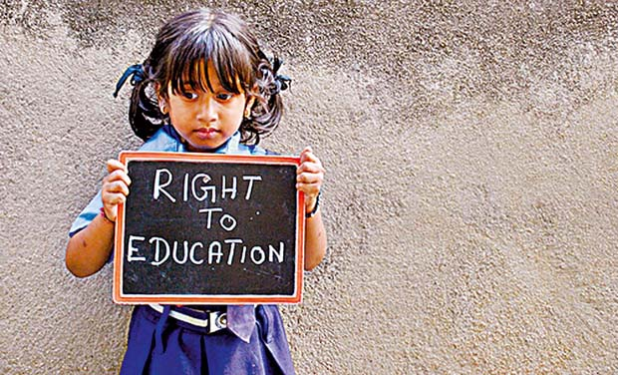***SUMMARY :***

The Right of Children to Free and Compulsory Education Act, provides for free and compulsory education as a fundamental right of every child in the 6-14 age group and earmarks 25 per cent seats to children from economically weaker sections in private schools. But going by the data source of National Sample Survey Office the literacy rate of children below 15 years is as low as 75.4 (which are marginally low in the rural areas(70.8) as compared to the urban (83.2) ).

And hence an effective digitalized computer program can effectively collect and match the relevant information at the local level and thereby giving significant and well adapted improvement to this literacy rates of our country.

|  |  |  |
| --- | --- | --- |
| S No. | Topic | Page No. |
| 1. | Acknowledgment | 1 |
| 2. | Introduction | 2-4 |
| 3. | Methodology | 5-9 |
| 4. | Conclusion | 10 |
| 5. | References | 11 |

Table Of Content :

**ACKNOWLEDGMENT :**

I Ashish Singh would like to thank my elder brother

working in the Ministry of Defence of GOI for helping me to research at relevant levels .

I would also like to thank my friend Garvit for going through the draft and suggesting some mandatory changes

**1**

**INTRODUCTION :**

The objective of this programme is to improvise the low literacy rates of children among the age group (6-14) by targeting the right audience through digitalized ways and improving the participation of children belonging to the rural and poor areas . RTE Act says that the state government or local authorities will determine the neighborhood schools by undertaking school mapping . Such agencies shall ensure that no child is subjected to caste , class , religious or gender abuse in school .

The local authority must conduct a household survey and maintain a record of all children in its jurisdiction. The record will contain detailed information about the child and his/her parents, and will specify whether the child belongs to the weaker section or disadvantaged group or having any disability.

The state government or local authorities will identify children with disabilities and children from disadvantaged groups every year.

Unaided and private schools shall ensure that children from weaker sections and disadvantaged groups shall not be segregated from the other children in the classrooms nor shall their classes be held at places and timings different from the classes held for the other children.

**2**

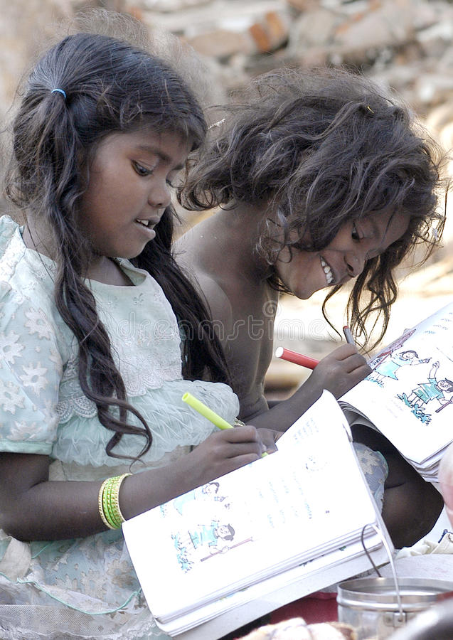

**3**

So the application here matches the data of all the children born before (6-14 years) and having the BPL card to the total card holders aligned with the school monitoring services . This will be done in a phased manner which will cover the entire population comprising of

1. BPL card holders
2. APL card holders

As the children belonging to the below poverty line community have lower chances of taking in admission due to their financial backgrounds . As we see a lot of children from these families are indulge in activities like child labor and other household activities .

And thus there is an urgent need to target this audience and make them understand the importance of elementary education of children and thus helping in improvised literacy rates and effective implementation of RTE act in our country .

4

**Methodology/Explanation :**

Lives matter , data scales . Data these days is harmful and fluctuating . And a solid way to keep an eye on it is by regularly updating it .

Well without beating around the bush here we go as :

**Points of consideration :**

1. Each child born is being registered via local authorities in a particular district . According to the law since 1969 , registration of births is compulsory as per provisions by Registration of Births & Deaths Act .

Birth certificates are being issued by the GOI . And hence the data can be easily collected from the local authorities .

From the above data we can easily abstract all the births in BPL families in a year by using SQL queries .

2. The data of people falling under Below Poverty Line is available with the district authorities and hence we can collect the data of every child born within this community as most of the children falling under this category are not prone to the elementary education . Due to certain family and financial issues of their own .

**5**

3. School councils in a particular area can provide the list of all the admissions being taken in a particular year .

Prior to this we can easily compare this data to the birth data ( 6 years back) in order to determine roughly the amount of admissions needed to be taken this year . And we can also abstract the list of admitted students falling within the BPL group and who have registered in the school using RTE ACT 2009 .

**USE OF THE ABOVE DATA ?**

From the above data we can segregate children into two categories as follows:

A. Children belonging to the BPL family and have taken admission in school .

B. Children belonging to the BPL family and haven’t taken admission in any school yet .

Now need of the hour is to selectively target and aware the people belonging to the point B referred above . As there might be certain miscellaneous and casualties like that which can be taken later on count such as migration of these people , deaths below the age of 6, false or not made birth certificates .

In the later slides we will discuss the ways to improvise and awaren the public .

**6**

***Awaken Netizens :***

People need to be aware of the facilities RTE gift them such as :

1. The child or his parents are not to be subjected to any screening procedure for admission to school
2. Special training provision for a child of above six years not been admitted to any school or, unable to continue studies, to bring him par with his class and to be admitted in an age appropriate class. In such cases, the child can continue beyond 14 years to complete his/her elementary education.
3. If a school does not provide facility to complete elementary education then a child of that school can take a transfer to any other government (govt.) or government-aided school.
4. Each child is also entitled to free text books, writing material and uniform.
5. The appropriate govt. which means central or state government and its affiliates have to provide a school within 1 km walking distance for children in classes I to V and within 3 kms for those in classes VI to VIII. These schools are termed as ‘neighborhood schools’.

**7**

1. The government has the responsibility to undertake school mapping to determine the location of the school.

**Various methods can be applied as follows :**

1. The data of children belonging to that BPL community and have not taken admission yet must be fast forwarded and uploaded to a government translucent website . The order and mandatory plans in order to monitor this admissions must be headed to the DM office or equivalent by the state government .

Also this data can be published in newspapers or radio stations for backward places where the facilities of internet aren’t that vast .

2. Online registration or offline registration at district headquarters must be conducted for the children whose name has been not displayed in the above list due to some casualties or lost data . The local authorities can meanwhile verify for authentication and can later the data on website .

Such that this or the required targeted audience can be taken under consideration which can significantly change the status of literacy in India and specially the rural areas .

**8**

Various organizations and NGO’s can conduct campaigns in the area where the population of BPL card holders is large and backward .

No school fees, capitation fees, charges or expenses are to be paid by a child to get elementary education , RTE suggests.

**Note: Gov. is providing free education to the age group 6-14years**

**old, the above process is just an idea for only 1 year i.e., when child**

**is of 6year old for full consideration of age group 6-14years we**

**need the data of 8 years and mining them in the same manner.**

**9**

CONCLUSION :

Since its enactment, the RTE Act has achieved success in overall enrolment rates but has faced criticism for administrative and structural lapses. Several provisions have fallen short of achieving their intended effect of significantly improving the quality of learning. While some provisions have failed due to implementation hurdles, others struggle due to a lack of coordination and the paucity of funds or delay in allocation. Moreover, the Act has since undergone certain amendments that tend to run contrary to the law’s spirit.

And hence our program will surely help in fair functioning of the local bodies with improved literacy rates in our country .

|  |  |  |
| --- | --- | --- |
| Year | No. of students enrolled in class VI-VIII (upper primary) | Year-on-year increase (in %) |
| 2007-08 | 50,911,110 | NA |
| 2009-10 | 54,467,415 | 6.5 |
| 2011-12 | 61,955,154 | 12 |
| 2013-14 | 66,471,219 | 6.8 |
| 2015-16 | 67,593,727 | 1.7 |

**10**

**REFERENCES :**

**Source:** Enrolment in Institutions and Schools (All India and State Wise), Ministry of Statistics and Programme Implementation, Government of India

<https://www.thehindu.com/features/education/school/RTE-Act-stipulates-school-mapping-household-surveys/article16840344.ece#:~:text=Such%20agencies%20shall%20ensure%20that,all%20children%20in%20its%20jurisdiction>

<https://snehadharafoundation.org/2017/08/09/the-right-approach-features-of-rte-act-2009/>

**11**